The amount is not been captured
Zip Zap cash deposit (Chrome)
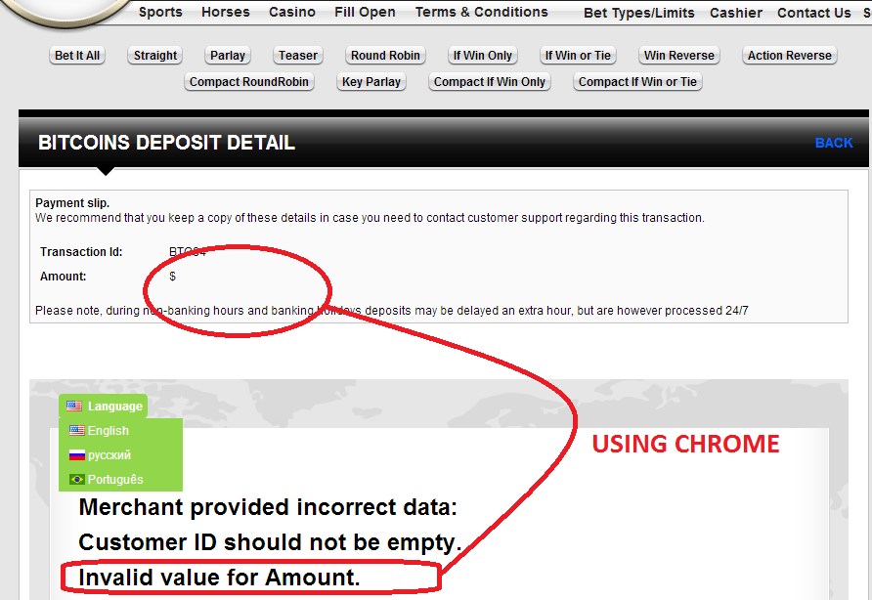
Zip Zap cash deposit (Firefox)
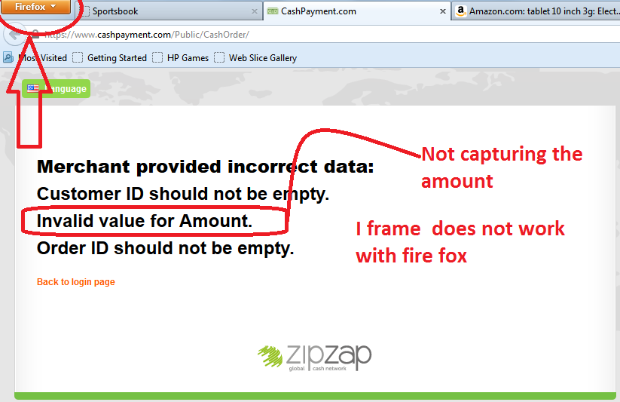
Zip Zap Cash deposit (explorer)
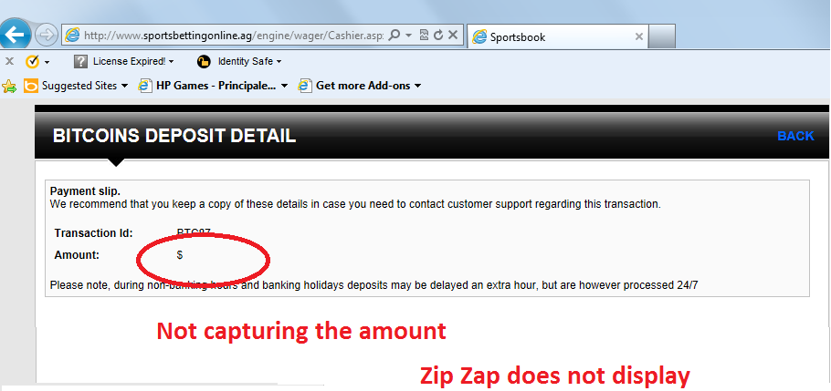

Coinbase ( CHROME)
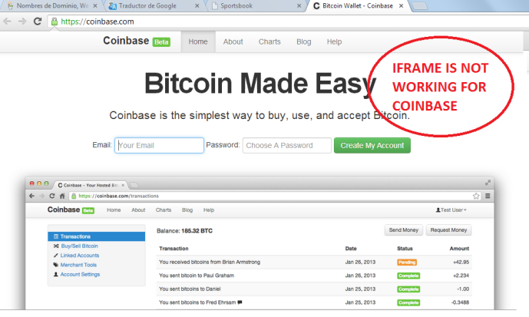

Coinbase ( Explorer)
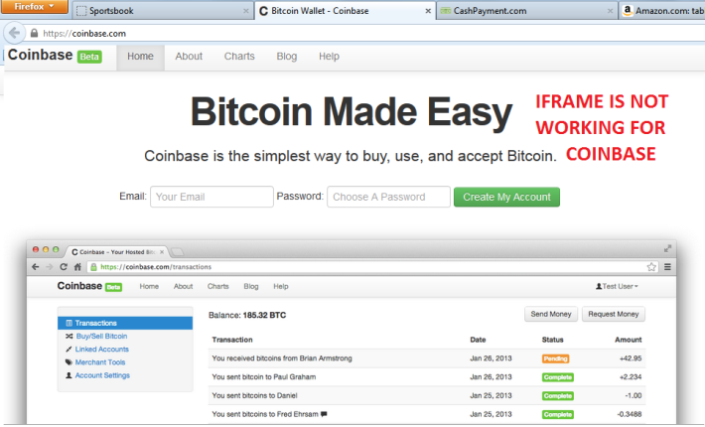

Coinbase ( Explorer)
